**Basic-level Questions**

**1. Explain Machine Learning, Artificial Intelligence, and Deep Learning**

It is common to get confused between the three in-demand technologies, Machine Learning, Artificial Intelligence, and Deep Learning. These three technologies, though a little different from one another, are interrelated. While Deep Learning is a subset of Machine Learning, Machine Learning is a subset of Artificial Intelligence. Since some terms and techniques may overlap in these technologies, it is easy to get confused among them.



So, let us learn about these technologies in detail:

* Machine Learning: Machine Learning involves various statistical and Deep Learning techniques that allow machines to use their past experiences and get better at performing specific tasks without having to be monitored.
* Artificial Intelligence: Artificial Intelligence uses numerous Machine Learning and Deep Learning techniques that enable computer systems to perform tasks using human-like intelligence with logic and rules. Artificial intelligence is used in every sector hence it is necessary to pursue [Artificial Intelligence Course](https://intellipaat.com/artificial-intelligence-deep-learning-course-with-tensorflow/) to make your career in AI.
* [Deep Learning](https://intellipaat.com/blog/tutorial/machine-learning-tutorial/introduction-deep-learning/): Deep Learning comprises several algorithms that enable software to learn from themselves and perform various business tasks including image and speech recognition. Deep Learning is possible when systems expose their multilayered neural networks to large volumes of data for learning.

***Willing to master AI & ML skills? Check our***[***AI and Machine Learning Courses***](https://intellipaat.com/course-cat/artificial-intelligence-and-machine-learning-courses/)***in collaboration with top universities Now!***

**2. What is Bias and Variance in Machine Learning?**

* Bias is the difference between the average prediction of a model and the correct value of the model. If the bias value is high, then the prediction of the model is not accurate. Hence, the bias value should be as low as possible to make the desired predictions.
* Variance is the number that gives the difference of prediction over a training set and the anticipated value of other training sets. High variance may lead to large fluctuation in the output. Therefore, a model’s output should have low variance.

The following diagram shows the bias-variance trade-off:

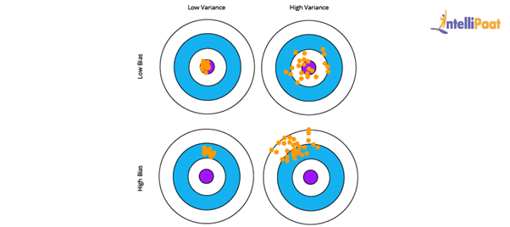

Here, the desired result is the blue circle at the center. If we get off from the blue section, then the prediction goes wrong.

***Interested in learning Machine Learning? Enroll in our***[***Machine Learning Training***](https://intellipaat.com/machine-learning-certification-training-course/)***now!***

**3. What is Clustering in Machine Learning?**

Clustering is a technique used in unsupervised learning that involves grouping data points. The clustering algorithm can be used with a set of data points. This technique will allow you to classify all data points into their particular groups. The data points that are thrown into the same category have similar features and properties, while the data points that belong to different groups have distinct features and properties. Statistical data analysis can be performed by this method. Let us take a look at three of the most popular and useful clustering algorithms.

* K-means clustering: This algorithm is commonly used when there is data with no specific group or category. K-means clustering allows you to find the hidden patterns in the data, which can be used to classify the data into various groups. The variable *k* is used to represent the number of groups the data is divided into, and the data points are clustered using the similarity of features. Here, the centroids of the clusters are used for labeling new data.
* Mean-shift clustering: The main aim of this algorithm is to update the center-point candidates to be mean and find the center points of all groups. In mean-shift clustering, unlike k-means clustering, the possible number of clusters need not be selected as it can automatically be discovered by the mean shift.
* Density-based spatial clustering of applications with noise (DBSCAN): This clustering algorithm is based on density and has similarities with mean-shift clustering. There is no need to preset the number of clusters, but unlike mean-shift clustering, DBSCAN identifies outliers and treats them like noise. Moreover, it can identify arbitrarily-sized and -shaped clusters without much effort.

**4. What is Linear Regression in Machine Learning?**

[Linear Regression](https://intellipaat.com/blog/what-is-linear-regression/) is a supervised Machine Learning algorithm. It is used to find the linear relationship between the dependent and independent variables for predictive analysis.

The equation for Linear Regression:



where:

* X is the input or independent variable
* Y is the output or dependent variable
* a is the intercept, and b is the coefficient of X

Below is the best-fit line that shows the data of weight, Y or the dependent variable, and the

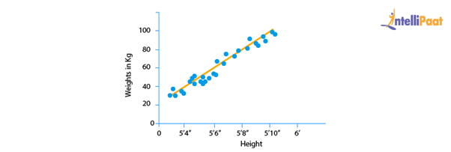

ata of height, X or the independent variable, of 21-year-old candidates scattered over the plot. The straight line shows the best linear relationship that would help in predicting the weight of candidates according to their height.

To get this best-fit line, the best values of a and b should be found. By adjusting the values of a and b, the errors in the prediction of Y can be reduced.

This is how linear regression helps in finding the linear relationship and predicting the output.

**5. What is a Decision Tree in Machine Learning?**

A [decision tree](https://intellipaat.com/blog/decision-tree-algorithm-in-machine-learning/) is used to explain the sequence of actions that must be performed to get the desired output. It is a hierarchical diagram that shows the actions.

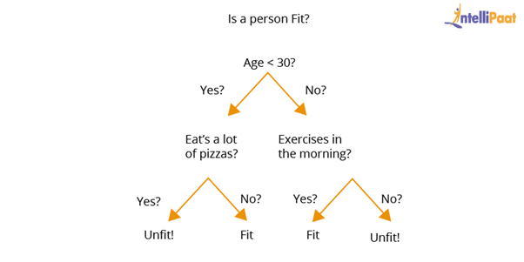

An algorithm can be created for a decision tree on the basis of the set hierarchy of actions.

In the above decision-tree diagram, a sequence of actions has been made for driving a vehicle with or without a license.

**6. What is Overfitting in Machine Learning and how can it be avoided?**

Overfitting happens when a machine has an inadequate dataset and tries to learn from it. So, overfitting is inversely proportional to the amount of data.

For small databases, overfitting can be bypassed by the cross-validation method. In this approach, a dataset is divided into two sections. These two sections will comprise the testing and training dataset. To train a model, the training dataset is used, and for testing the model for new inputs, the testing dataset is used.  
This is how to avoid overfitting.

**7. What is Hypothesis in Machine Learning?**

Machine Learning allows the use of available dataset to understand a specific function that maps input to output in the best possible way. This problem is known as function approximation. Here, approximation needs to be used for the unknown target function that maps all plausible observations based on the given problem in the best manner. Hypothesis in Machine learning is a model that helps in approximating the target function and performing the necessary input-to-output mappings. The choice and configuration of algorithms allow defining the space of plausible hypotheses that may be represented by a model.

In the hypothesis, lowercase h (h) is used for a specific hypothesis, while uppercase h (H) is used for the hypothesis space that is being searched. Let us briefly understand these notations:

* Hypothesis (h): A hypothesis is a specific model that helps in mapping input to output; the mapping can further be used for evaluation and prediction.
* Hypothesis set (H): Hypothesis set consists of a space of hypotheses that can be used to map inputs to outputs, which can be searched. The general constraints include the choice of problem framing, the model, and the model configuration.

**8. What are the differences between Deep Learning and Machine Learning?**

* Deep Learning: Deep Learning allows machines to make various business-related decisions using artificial neural networks, which is one of the reasons why it needs a vast amount of data for training. Since there is a lot of computing power required, Deep Learning requires high-end systems as well. The systems acquire various properties and features with the help of the given data, and the problem is solved using an end-to-end method.
* Machine Learning: Machine Learning gives machines the ability to make business decisions without any external help, using the knowledge gained from past data. Machine Learning systems require relatively small amounts of data to train themselves, and most of the features need to be manually coded and understood in advance. In Machine Learning, a given business problem is dissected into two and then solved individually. Once the solutions of both have been acquired, they are then combined.

**9. What are the differences between Supervised and Unsupervised Machine Learning?**

* Supervised learning: The algorithms of supervised learning use labeled data to get trained. The models take direct feedback to confirm whether the output that is being predicted is, indeed, correct. Moreover, both the input data and the output data are provided to the model, and the main aim here is to train the model to predict the output upon receiving new data. Supervised learning offers accurate results and can largely be divided into two parts, classification and regression.
* Unsupervised learning: The algorithms of unsupervised learning use unlabeled data for training purposes. In unsupervised learning, the models identify hidden data trends and do not take any feedback. The unsupervised learning model is only provided with input data. Unsupervised learning’s main aim is to identify hidden patterns to extract information from unknown sets of data. It can also be classified into two parts, clustering, and associations. Unfortunately, unsupervised learning offers results that are comparatively less accurate.

**Learn more about Machine Learning from this**[**Machine Learning tutorial**](https://intellipaat.com/blog/tutorial/machine-learning-tutorial/)**!**

**10. What is Bayes’s Theorem in Machine Learning?**

Bayes’s theorem offers the probability of any given event to occur using prior knowledge. In mathematical terms, it can be defined as the true positive rate of the given sample condition divided by the sum of the true positive rate of the said condition and the false positive rate of the entire population.

Two of the most significant applications of Bayes’s theorem in Machine Learning are Bayesian optimization and Bayesian belief networks. This theorem is also the foundation behind the Machine Learning brand that involves the Naive Bayes classifier.

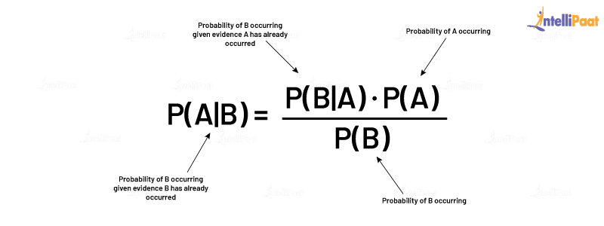

**11. What is PCA in Machine Learning?**

Multidimensional data is at play in the real world. Data visualization and computation become more challenging with the increase in dimensions. In such a scenario, the dimensions of data might have to be reduced to analyze and visualize it easily. This is done by:

* Removing irrelevant dimensions
* Keeping only the most relevant dimensions

This is where [Principal Component Analysis](https://intellipaat.com/blog/a-brief-introduction-to-principal-component-analysis/) (PCA) is used.

The goal of PCA is to find a fresh collection of uncorrelated dimensions (orthogonal) and rank them on the basis of variance.

Mechanism of PCA:

* Compute the covariance matrix for data objects
* Compute eigenvectors and eigenvalues in descending order
* Select the initial *N* eigenvectors to get new dimensions
* Finally, change the initial n-dimensional data objects into N-dimensions

**Example:** Below are two graphs showing data points or objects and two directions, one is green and the other is yellow. Graph 2 is arrived at by rotating Graph 1 so that the x-axis and y-axis represent the green and yellow direction respectively.

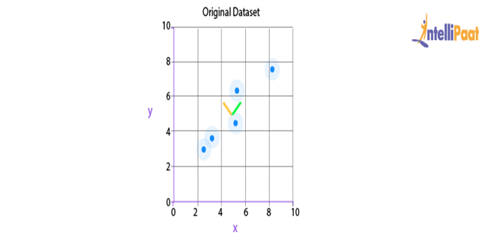

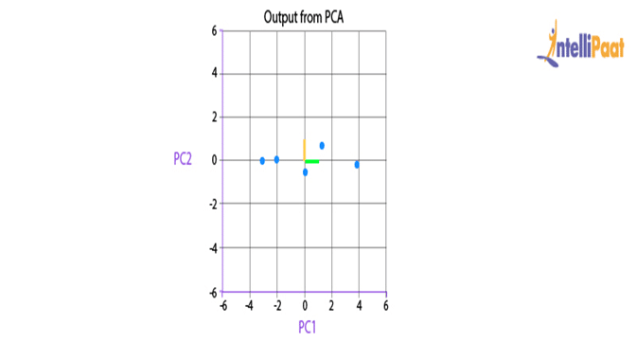

After the rotation of data points, it can be inferred that the green direction, the x-axis, gives the line that best fits the data points.

Here, two-dimensional data is being represented; but in real life, the data would be multidimensional and complex. So, after recognizing the importance of each direction, the area of dimensional analysis can be reduced by cutting off the less-significant directions.

Now, we will go through another important Machine Learning interview question on PCA.

**12. What is Support Vector Machine (SVM) in Machine Learning?**

[SVM](https://intellipaat.com/blog/tutorial/machine-learning-tutorial/svm-algorithm-in-python/) is a Machine Learning algorithm that is majorly used for classification. It is used on top of the high dimensionality of the characteristic vector.

The following is the code for SVM classifier:

# Introducing required libraries

from sklearn import datasets

from sklearn.metrics import confusion_matrix

from sklearn.model_selection import train_test_split

# Stacking the Iris dataset

iris = datasets.load_iris()

# A -> features and B -> label

A = iris.data

B = iris.target

# Breaking A and B into train and test data

A_train, A_test, B_train, B_test = train_test_split(A, B, random_state = 0)

# Training a linear SVM classifier

from sklearn.svm import SVC

svm_model_linear = SVC(kernel = 'linear', C = 1).fit(A_train, B_train)

svm_predictions = svm_model_linear.predict(A_test)

# Model accuracy for A_test

accuracy = svm_model_linear.score(A_test, B_test)

# Creating a confusion matrix

cm = confusion_matrix(B_test, svm_predictions)

**13. What is Cross-validation in Machine Learning?**

Cross-validation allows a system to increase the performance of the given Machine Learning algorithm, which is fed a number of sample data from the dataset. This sampling process is done to break the dataset into smaller parts that have the same number of rows, out of which a random part is selected as a test set and the rest of the parts are kept as train sets. Cross-validation consists of the following techniques:

* Holdout method
* K-fold cross-validation
* Stratified k-fold cross-validation
* Leave p-out cross-validation

**14. What is Entropy in Machine Learning?**

Entropy in Machine Learning measures the randomness in the data that needs to be processed. The more entropy in the given data, the more difficult it becomes to draw any useful conclusion from the data. For example, let us take the flipping of a coin. The result of this act is random as it does not favor heads or tails. Here, the result for any number of tosses cannot be predicted easily as there is no definite relationship between the action of flipping and the possible outcomes.

**15. What is Epoch in Machine Learning?**

[Epoch in Machine Learning](https://intellipaat.com/blog/epoch-in-machine-learning/) is used to indicate the count of passes in a given training dataset where the Machine Learning algorithm has done its job. Generally, when there is a large chunk of data, it is grouped into several batches. All these batches go through the given model, and this process is referred to as iteration. Now, if the batch size comprises the complete training dataset, then the count of iterations is the same as that of epochs.  
In case there is more than one batch, d*e=i*b is the formula used, wherein d is the dataset, e is the number of epochs, i is the number of iterations, and b is the batch size.

**Intermediate-level Questions**

**16. What are the types of Machine Learning?**

This is one of the most basic interview questions that everyone must know.

So, basically, there are three [types of Machine Learning](https://intellipaat.com/blog/tutorial/machine-learning-tutorial/types-of-machine-learning/). They are described as follows:

[Supervised learning](https://intellipaat.com/blog/what-is-supervised-learning/): In this type of Machine Learning, machines learn under the supervision of labeled data. There is a training dataset on which a machine is trained, and it gives the output according to its training.

three types of Machine Learning techniques

Unsupervised learning: This type of Machine Learning has unlabeled data unlike supervised learning. Unsupervised learning works on data under absolutely no supervision. Unsupervised learning tries to identify patterns in data and makes clusters of similar entities. After that, when a new input data is fed into the model, it does not identify the entity; rather, it puts the entity in a cluster of similar objects.



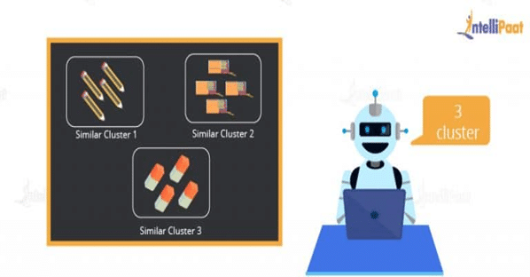

[Reinforcement learning](https://intellipaat.com/blog/what-is-reinforcement-learning/): Reinforcement learning includes models that learn and traverse to find the best possible move. The algorithms for reinforcement learning are constructed in a way that they try to find the best possible suite of action on the basis of the reward and punishment theory.

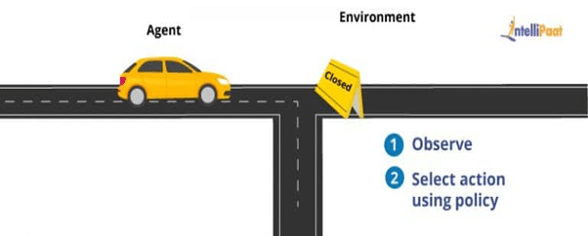

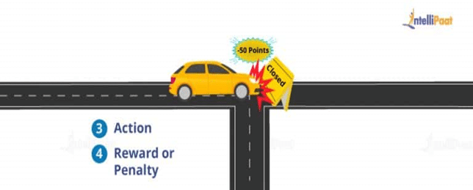

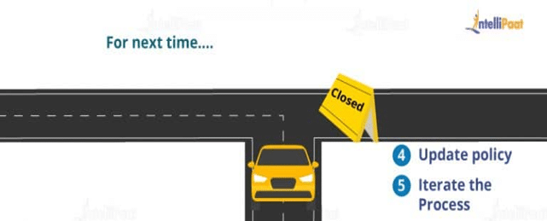

**17. Differentiate between Classification and Regression in Machine Learning**

In Machine Learning, there are various types of prediction problems based on supervised and unsupervised learning. They are classification, regression, clustering, and association. Here, we will discuss classification and regression.

Classification: In [classification](https://intellipaat.com/blog/tutorial/machine-learning-tutorial/classification-machine-learning/), a Machine Learning model is created that assists in differentiating data into separate categories. The data is labeled and categorized based on the input parameters.

For example, predictions have to be made on the churning out customers for a particular product based on some recorded data. Either the customers will churn out or they will not. So, the labels for this would be “Yes” and “No.”

Regression: It is the process of creating a model for distinguishing data into continuous real values, instead of using classes or discrete values. It can also identify the distribution movement depending on historical data. It is used for predicting the occurrence of an event depending on the degree of association of variables.

For example, the prediction of weather conditions depends on factors such as temperature, air pressure, solar radiation, elevation, and distance from the sea. The relation among these factors assists in predicting the weather condition.

**18. How is the suitability of a Machine Learning Algorithm determined for a particular problem?**

To identify a [Machine Learning Algorithm](https://intellipaat.com/blog/tutorial/machine-learning-tutorial/machine-learning-algorithms/) for a particular problem, the following steps should be followed:

**Step 1:** Problem classification: Classification of the problem depends on the classification of input and output:

* Classifying the input: Classification of the input depends on whether there is data labeled (supervised learning) or unlabeled (unsupervised learning), or whether a model has to be created that interacts with the environment and improves itself (reinforcement learning.)
* Classifying the output: If the output of a model is required as a class, then some classification techniques need to be used.

If the output is a number, then regression techniques must be used; if the output is a different cluster of inputs, then clustering techniques should be used.

**Step 2:** Checking the algorithms in hand: After classifying the problem, the available algorithms that can be deployed for solving the classified problem should be considered.

**Step 3:** Implementing the algorithms: If there are multiple algorithms available, then all of them are to be implemented. Finally, the algorithm that gives the best performance is selected.

**19. What is the Variance Inflation Factor?**

Variance inflation factor (VIF) is the estimate of the volume of multicollinearity in a collection of many regression variables.

VIF = Variance of the model / Variance of the model with a single independent variable

This ratio has to be calculated for every independent variable. If VIF is high, then it shows the high collinearity of the independent variables.

**20. What is a Confusion Matrix?**

[Confusion matrix](https://intellipaat.com/blog/confusion-matrix-python/) is used to explain a model’s performance and gives a summary of predictions of the classification problems. It assists in identifying the uncertainty between classes.

Confusion matrix gives the count of correct and incorrect values and error types. Accuracy of the model:

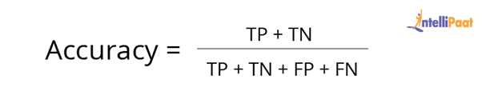

For example, consider the following confusion matrix. It consists of values as true positive, true negative, false positive, and false negative for a classification model. Now, the accuracy of the model can be calculated as follows:



So, in the example:

Accuracy = (200 + 50) / (200 + 50 + 10 + 60) = 0.78

This means that the model’s accuracy is 0.78, corresponding to its True Positive, True Negative, False Positive, and False Negative values.

**21. What are Type I and Type II Errors?**

**Type I Error:** Type I Error, false positive, is an error where the outcome of a test shows the nonacceptance of a true condition.

For example, suppose a person gets diagnosed with depression even when they are not suffering from the same, it is a case of false positive.

**Type II Error:** Type II Error, false negative, is an error where the outcome of a test shows the acceptance of a false condition.

For example, the CT scan of a person shows that they do not have a disease but in fact they do have the disease. Here, the test accepts the false condition that the person does not have the disease. This is a case of false negative.

**22. When should Classification be used over Regression?**

Both classification and regression are associated with prediction. Classification involves the identification of values or entities that lie in a specific group. Regression entails predicting a response value from consecutive sets of outcomes.

Classification is chosen over regression when the output of the model needs to yield the belongingness of data points in a dataset to a particular category.

For example, If you want to predict the price of a house, you should use regression since it is a numerical variable. However, if you are trying to predict whether a house situated in a particular area is going to be high-, medium-, or low-priced, then a classification model should be used.

**23. Explain Logistic Regression**

[Logistic regression](https://intellipaat.com/blog/what-is-logistic-regression/) is the proper regression analysis used when the dependent variable is categorical or binary. Like all regression analyses, logistic regression is a technique for [predictive analysis](https://intellipaat.com/blog/what-is-predictive-analytics/). Logistic regression is used to explain data and the relationship between one dependent binary variable and one or more independent variables. Logistic regression is also employed to predict the probability of categorical dependent variables.

Logistic regression can be used in the following scenarios:

* To predict whether a citizen is a Senior Citizen (1) or not (0)
* To check whether a person has a disease (Yes) or not (No)

There are three types of logistic regression:

* Binary logistic regression: In this type of logistic regression, there are only two outcomes possible.

Example: To predict whether it will rain (1) or not (0)

* Multinomial logistic regression: In this type of logistic regression, the output consists of three or more unordered categories.

Example: Predicting whether the prize of the house is high, medium, or low.

* Ordinal logistic regression: In this type of logistic regression, the output consists of three or more ordered categories.

Example: Rating an Android application from one to five stars.

***Interested in learning Machine Learning? Enroll in this***[***Machine Learning Training in Bangalore***](https://intellipaat.com/machine-learning-certification-training-course-bangalore/)***!***

**24. How to handle Missing or Corrupted Data in a Dataset?**

In Python pandas, there are two methods to locate lost or corrupted data and discard those values:

* isNull(): It can be used for detecting the missing values.
* dropna(): It can be used for removing columns or rows with null values.

fillna() can be used to fill the void values with placeholder values.

**25. Why is rotation required in PCA? What will happen if the components are not rotated?**

Rotation is a significant step in principal component analysis (PCA.) Rotation maximizes the separation within the variance obtained by the components. This makes the interpretation of the components easier.

The motive behind conducting PCA is to choose fewer components that can explain the greatest variance in a dataset. When rotation is performed, the original coordinates of the points get changed. However, there is no change in the relative position of the components.

If the components are not rotated, then there needs to be more extended components to describe the variance.

**26. What is ROC Curve and what does it represent?**

ROC stands for receiver operating characteristic. [ROC Curve](https://intellipaat.com/blog/roc-curve-in-machine-learning/) is used to graphically represent the trade-off between true and false-positive rates.

In ROC, the area under the curve (AUC) gives an idea about the accuracy of the model.

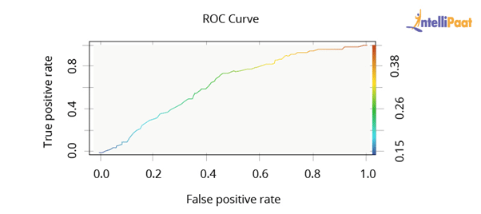

The above graph shows a ROC curve. The greater the AUC, the better the performance of the model.

Next, we will be taking a look at Machine Learning interview questions on rescaling, binarizing, and standardizing.

**27. Why are Validation and Test Datasets Needed?**

Data is split into three different categories while creating a model:

* **Training dataset:** Training dataset is used for building a model and adjusting its variables. The correctness of the model built on the training dataset cannot be relied on as the model might give incorrect outputs after being fed new inputs.
* **Validation dataset:** Validation dataset is used to look into a model’s response. After this, the hyperparameters on the basis of the estimated benchmark of the validation dataset data are tuned.When a model’s response is evaluated by using the validation dataset, the model is indirectly trained with the validation set. This may lead to the overfitting of the model to specific data. So, this model will not be strong enough to give the desired response to real-world data.
* **Test dataset:** Test dataset is the subset of the actual dataset, which is not yet used to train the model. The model is unaware of this dataset. So, by using the test dataset, the response of the created model can be computed on hidden data. The model’s performance is tested on the basis of the test dataset.Note: The model is always exposed to the test dataset after tuning the hyperparameters on top of the validation dataset.

As we know, the evaluation of the model on the basis of the validation dataset would not be enough. Thus, the test dataset is used for computing the efficiency of the model.

[](https://intellipaat.com/post-graduate-certification-big-data-analytics/)

**28. Explain the difference between KNN and K-means Clustering**

**K-nearest neighbors (KNN):** It is a supervised Machine Learning algorithm. In KNN, identified or labeled data is given to the model. The model then matches the points based on the distance from the closest points.

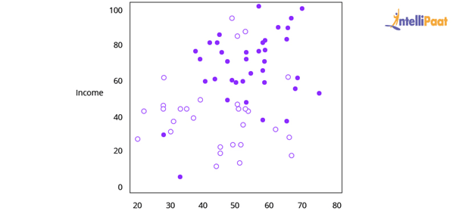

[K-means clustering](https://intellipaat.com/blog/k-means-clustering/): It is an unsupervised Machine Learning algorithm. In K-means clustering, unidentified or unlabeled data is given to the model. The algorithm then creates batches of points based on the average of the distances between distinct points.

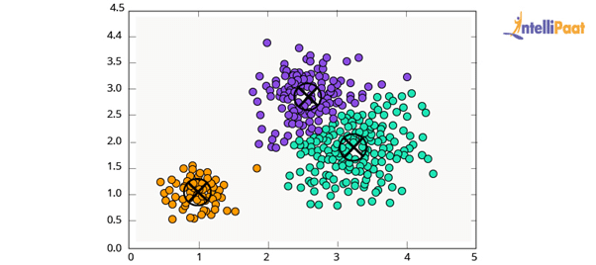

**29. What is Dimensionality Reduction?**

In the real world, Machine Learning models are built on top of features and parameters. These features can be multidimensional and large in number. Sometimes, the features may be irrelevant and it becomes a difficult task to visualize them.

This is where dimensionality reduction is used to cut down irrelevant and redundant features with the help of principal variables. These principal variables conserve the features, and are a subgroup, of the parent variables.

**30. Both being Tree-based Algorithms, how is Random Forest different from Gradient Boosting Machine (GBM)?**

The main difference between a random forest and GBM is the use of techniques. [Random forest](https://intellipaat.com/blog/what-is-random-forest-algorithm-in-python/) advances predictions using a technique called bagging. On the other hand, GBM advances predictions with the help of a technique called boosting.

* **Bagging:** In bagging, we apply arbitrary sampling and we divide the dataset into *N.* After that, we build a model by employing a single training algorithm. Following that, we combine the final predictions by polling. Bagging helps to increase the efficiency of a model by decreasing the variance to eschew overfitting.
* **Boosting:** In boosting, the algorithm tries to review and correct the inadmissible predictions at the initial iteration. After that, the algorithm’s sequence of iterations for correction continues until we get the desired prediction. Boosting assists in reducing bias and variance for strengthening the weak learners.

**31. What is meant by Parametric and Non-parametric Models?**

Parametric models refer to the models having a limited number of parameters. In case of parametric models, only the parameter of a model is needed to be known to make predictions regarding the new data.

Non-parametric models do not have any restrictions on the number of parameters, which makes new data predictions more flexible. In case of non-parametric models, the knowledge of model parameters and the state of the data needs to be known to make predictions.

**32. Differentiate between Sigmoid and Softmax Functions**

Sigmoid and Softmax functions differ based on their usage in Machine Learning task classification. Sigmoid function is used in the case of binary classification, while Softmax function is used in case of multi-classification.

**33. In Machine Learning, for how many classes can Logistic Regression be used?**

Logistic regression cannot be used for more than two classes. Logistic regression is, by default, a binary classifier. However, in cases where multi-class classification problems need to be solved, the default number of classes can be extended, i.e., multinomial logistic regression.

**34. What do you understand about the P-value?**

P-value is used in decision-making while testing a hypothesis. The null hypothesis is rejected at the minimum significance level of the P-value. A lower P-value indicates that the null hypothesis is to be rejected.

**35. What is meant by Correlation and Covariance?**

Correlation is a mathematical concept used in statistics and probability theory to measure, estimate, and compare data samples taken from different populations. In simpler terms, correlation helps in establishing a quantitative relationship between two variables.

Covariance is also a mathematical concept; it is a simpler way to arrive at a correlation between two variables. Covariance basically helps in determining what change or affect does one variable has on another.

**36. What are the Various Tests for Checking the Normality of a Dataset?**

In Machine Learning, checking the normality of a dataset is very important. Hence, certain tests are performed on a dataset to check its normality. Some of them are:

* D’Agostino Skewness Test
* Shapiro-Wilk Test
* Anderson-Darling Test
* Jarque-Bera Test
* Kolmogorov-Smirnov Test

**37. What are the Two Main Types of Filtering in Machine Learning? Explain.**

The two types of filtering are:

* Collaborative filtering
* Content-based filtering

Collaborative filtering refers to a recommender system where the interests of the individual user are matched with preferences of multiple users to predict new content.

Content-based filtering is a recommender system where the focus is only on the preferences of the individual user and not on multiple users.

**38. Outlier Values can be Discovered from which Tools?**

The various tools that can be used to discover outlier values are scatterplots, boxplots, Z-score, etc.

**39. What is meant by Ensemble Learning?**

Ensemble learning refers to the combination of multiple Machine Learning models to create more powerful models. The primary techniques involved in ensemble learning are bagging and boosting.

**40. What are the Various Kernels that are present in SVM?**

The various kernels that are present in SVM are:

* Linear
* Polynomial
* Radial Basis
* Sigmoid

**Advanced-level Questions**

**41. Suppose you found that your model is suffering from high variance. Which algorithm do you think could handle this situation and why?**

Handling High Variance

* For handling issues of high variance, we should use the bagging algorithm.
* The bagging algorithm would split data into subgroups with a replicated sampling of random data.
* Once the algorithm splits the data, we can use random data to create rules using a particular training algorithm.
* After that, we can use polling for combining the predictions of the model.

**42. What is Rescaling of Data and how is it done?**

In real-world scenarios, the attributes present in data are in a varying pattern. So, rescaling the characteristics to a common scale is beneficial for algorithms to process data efficiently.

We can rescale data using Scikit-learn. The code for rescaling the data using MinMaxScaler is as follows:

#Rescaling data

import pandas

import scipy

import numpy

from sklearn.preprocessing import MinMaxScaler

names = ['Abhi', 'Piyush', 'Pranay', 'Sourav', 'Sid', 'Mike', 'pedi', 'Jack', 'Tim']

Dataframe = pandas.read_csv(url, names=names)

Array = dataframe.values

# Splitting the array into input and output

X = array[:,0:8]

Y = array[:,8]

Scaler = MinMaxScaler(feature_range=(0, 1))

rescaledX = scaler.fit_transform(X)

# Summarizing the modified data

numpy.set_printoptions(precision=3)

print(rescaledX[0:5,:])

Apart from the theoretical concepts, some interviewers also focus on the implementation of Machine Learning topics. The following Interview Questions are related to the implementation of theoretical concepts.

**43. What is Binarizing of Data? How to Binarize?**

Converting data into binary values on the basis of threshold values is known as binarizing of data. The values that are less than the threshold are set to 0 and the values that are greater than the threshold are set to 1. This process is useful when feature engineering has to be performed. This can also be used for adding unique features. Data can be binarized using Scikit-learn. The code for binarizing data using Binarizer is as follows:

from sklearn.preprocessing import Binarizer

import pandas

import numpy

names = ['Abhi', 'Piyush', 'Pranay', 'Sourav', 'Sid', 'Mike', 'pedi', 'Jack', 'Tim']

dataframe = pandas.read_csv(url, names=names)

array = dataframe.values

# Splitting the array into input and output

X = array[:,0:8]

Y = array[:,8]

binarizer = Binarizer(threshold=0.0).fit(X)

binaryX = binarizer.transform(X)

# Summarizing the modified data

numpy.set_printoptions(precision=3)

print(binaryX[0:5,:])

**44. How to Standardize Data?**

Standardization is the method that is used for rescaling data attributes. The attributes are likely to have a mean value of 0 and a value of the standard deviation of 1. The main objective of standardization is to prompt the mean and standard deviation for the attributes.

Data can be standardized using [Scikit-learn](https://intellipaat.com/blog/tutorial/python-tutorial/scikit-learn-tutorial/). The code for standardizing the data using StandardScaler is as follows:

# Python code to Standardize data (0 mean, 1 stdev)

from sklearn.preprocessing import StandardScaler

import pandas

import numpy

names = ['Abhi', 'Piyush', 'Pranay', 'Sourav', 'Sid', 'Mike', 'pedi', 'Jack', 'Tim']

dataframe = pandas.read_csv(url, names=names)

array = dataframe.values

# Separate the array into input and output components

X = array[:,0:8]

Y = array[:,8]

scaler = StandardScaler().fit(X)

rescaledX = scaler.transform(X)

# Summarize the transformed data

numpy.set_printoptions(precision=3)

print(rescaledX[0:5,:])

**45. We know that one-hot encoding increases the dimensionality of a dataset, but label encoding doesn’t. How?**

When one-hot encoding is used, there is an increase in the dimensionality of a dataset. The reason for the increase in dimensionality is that every class in categorical variables, forms a different variable.

Example: Suppose there is a variable “Color.” It has three sublevels, “Yellow,” “Purple,” and “Orange.” So, one-hot encoding “Color” will create three different variables as Color.Yellow, Color.Purple, and Color.Orange.

In label encoding, the subclasses of a certain variable get the value 0 and 1. So, label encoding is only used for binary variables.

This is why one-hot encoding increases the dimensionality of data and label encoding does not.

*Now, if you are interested in doing an end-to-end certification course in Machine Learning, you can check out Intellipaat’s*[*Machine Learning Course*](https://intellipaat.com/machine-learning-certification-training-course/)*with Python.*

**46. Executing a binary classification tree algorithm is a simple task. But how does tree splitting take place? How does the tree determine which variable to break at the root node and which at its child nodes?**

Gini index and Node Entropy assist the binary classification tree to make decisions. Basically, the tree algorithm determines the feasible feature that is used to distribute data into the most genuine child nodes.

According to the Gini index, if we arbitrarily pick a pair of objects from a group, then they should be of identical class and the probability for this event should be 1.

The following are the steps to compute the Gini index:

1. Compute Gini for sub-nodes with the formula: The sum of the square of probability for success and failure (p^2 + q^2)
2. Compute Gini for split by weighted Gini rate of every node of the split

Now, Entropy is the degree of indecency that is given by the following:

Where *a* and *b* are the probabilities of success and failure of the node

When Entropy = 0, the node is homogenous

When Entropy is high, both groups are present at 50–50 percent in the node.

Finally, to determine the suitability of the node as a root node, the entropy should be very low.

**47. Imagine you are given a dataset consisting of variables having more than 30% missing values. Let’s say, out of 50 variables, 16 variables have missing values, which is higher than 30%. How will you deal with them?**

To deal with the missing values, we will do the following:

* We will specify a different class for the missing values.
* Now, we will check the distribution of values, and we will hold those missing values that are defining a pattern.
* Then, we will charge these values into yet another class while eliminating others.

**48. Explain False Negative, False Positive, True Negative, and True Positive with a simple example.**

**True Positive (TP):** When the Machine Learning model correctly predicts the condition, it is said to have a True Positive value.

**True Negative (TN):** When the Machine Learning model correctly predicts the negative condition or class, then it is said to have a True Negative value.

**False Positive (FP):** When the Machine Learning model incorrectly predicts a negative class or condition, then it is said to have a False Positive value.

**False Negative (FN):** When the Machine Learning model incorrectly predicts a positive class or condition, then it is said to have a False Negative value.

**49. What is F1-score and How Is It Used?**

F-score or F1-score is a measure of overall accuracy of a binary classification model. Before understanding F1-score, it is crucial to understand two more measures of accuracy, i.e., precision and recall.

Precision is defined as the percentage of True Positives to the total number of positive classifications predicted by the model. In other words,

Precision = (No. of True Positives / No. True Positives + No. of False Positives)

Recall is defined as the percentage of True Positives to the total number of actual positive labeled data passed to the model. In other words,

Precision = (No. of True Positives / No. True Positives + No. of False Negatives)

Both precision and recall are partial measures of accuracy of a model. F1-score combines precision and recall and provides an overall score to measure a model’s accuracy.

F1-score = 2 × (Precision × Recall) / (Precision + Recall)

This is why, F1-score is the most popular measure of accuracy in any Machine-Learning-based binary classification model.

**50. How to Implement the KNN Classification Algorithm?**

Iris dataset is used for implementing the KNN classification algorithm.

# KNN classification algorithm

from sklearn.datasets import load_iris

from sklearn.neighbors import KNeighborsClassifier

import numpy as np

from sklearn.model_selection import train_test_split

iris_dataset=load_iris()

A_train, A_test, B_train, B_test = ztrain_test_split(iris_dataset["data"], iris_dataset["target"], random_state=0)

kn = KNeighborsClassifier(n_neighbors=1)

kn.fit(A_train, B_train)

A_new = np.array([[8, 2.5, 1, 1.2]])

prediction = kn.predict(A_new)

print("Predicted target value: {}\n".format(prediction))

print("Predicted feature name: {}\n".format

(iris_dataset["target_names"][prediction]))

print("Test score: {:.2f}".format(kn.score(A_test, B_test)))

Output:

Predicted Target Name: [0]

Predicted Feature Name: [‘ Setosa’]

Test Score: 0.92